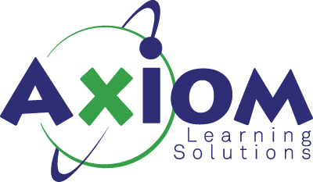

Advanced Developing on AWS
Course Length: 3 Days
Course Description:
The Advanced Developing on AWS course uses the real-world scenario of taking a legacy, on-premises monolithic application and refactoring it into a serverless microservices architecture. This three-day advanced course covers advanced development topics such as architecting for a cloud-native environment; deconstructing on-premises, legacy applications and repackaging them into cloud-based, cloud-native architectures; and applying the tenets of the Twelve-Factor Application methodology.
Course Objectives:
- Analyze a monolithic application architecture to determine logical or programmatic break points where the application can be broken up across different AWS services
- Apply Twelve-Factor Application manifesto concepts and steps while migrating from a monolithic architecture
- Recommend the appropriate AWS services to develop a microservices based cloud-native application
- Use the AWS API, CLI, and SDKs to monitor and manage AWS services
- Migrate a monolithic application to a microservices application using the 6 Rs of migration
- Explain the SysOps and DevOps interdependencies necessary to deploy a microservices application in AWS.
This course is intended for:
- Full Stack Developer
- Cloud Developer
- Software Developers
Prerequisites:
- In-depth knowledge of at least one high-level programming language
- Developing on AWS
- Working knowledge of core AWS services and public cloud implementation
Course Outline:
1) The Cloud Journey
- Common offcloud architecture
- Introduction to Cloud Air
- Monolithic architecture
- Migration to the cloud
- Guardrails
- The six Rs of migration
- The TwelveFactor Application Methodology
- Architectural styles and patterns
- Overview of AWS Services
- Interfacing with AWS Services
- Authentication
- Infrastructure as code and Elastic Beanstalk
- Demonstration Walk through creating base infrastructure with AWS CloudFormation in the AWS console
2) Gaining Agility
- DevOps
- CICD
- Application configuration
- Secrets management
- CICD Services in AWS
3) Monolith to MicroServices
- Microservices
- Serverless
- A look at Cloud Air
- Microservices using Lambda and API Gateway
- SAM
- Strangling the Monolith
4) Polyglot Persistence Distributed Complexity
- Polyglot persistence
- DynamoDB best practices
- Distributed complexity
- Steps functions
5) Resilience and Scale
- Decentralized data stores
- Amazon SQS
- Amazon SNS
- Amazon Kinesis Streams
- AWS IoT Message Broker
- Serverless event bus
- Event sourcing and CQRS
- Designing for resilience in the cloud
6) Security and Observability
- Serverless Compute with AWS Lambda
- Authentication with Amazon Cognito
- Debugging and traceability

